Sebastian Andres Soto Sandrea 40364726

Assignment 3 outputs:

Question 1:

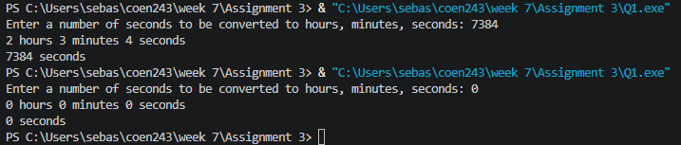

Question 2:
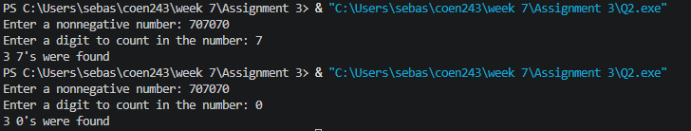

Question 3:

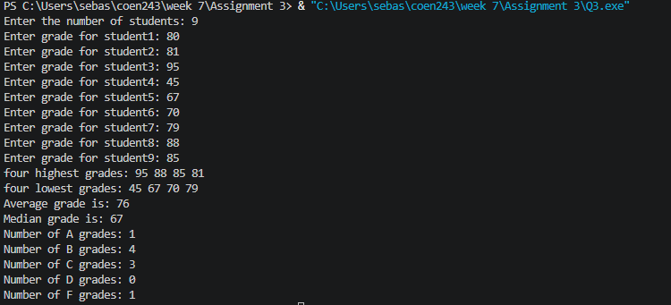
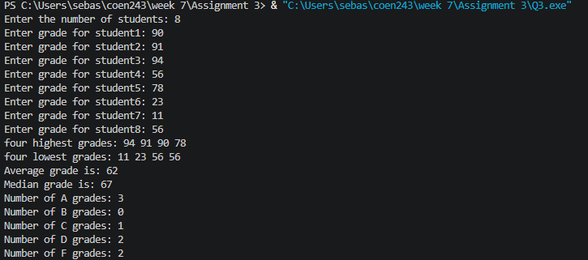

Question 4:

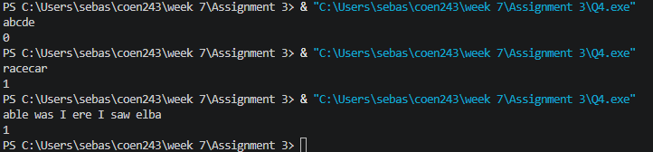

Question 5



